
Kingdom of Saudi Arabia
Ministry of Education
……..Education Directorate
………………… School
English Language
elementary Grade 3rd
2nd period Exam
…………….\20
الاسم: الصف:

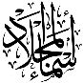
……\ 4 marks

General questions

A.Answer the questions
Congratulations! |  | I stayed home | 1
I cooked breakfast. |  | What happened to you yesterday? | 2
I caught a cold |  | What did you do over the weekend? | 3
That's boring. |  | I won a basketball game. | 4

Controlled Writing
……\ 1 marks
A-reorder.
1- outside \They \played.
a-They played outside b- outside played they

……\ 4 marks

Reading short sentence
 | 1- My uncle had an operation. ( )
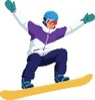 | 2- You can buy a snowboard at a sport store. ( )
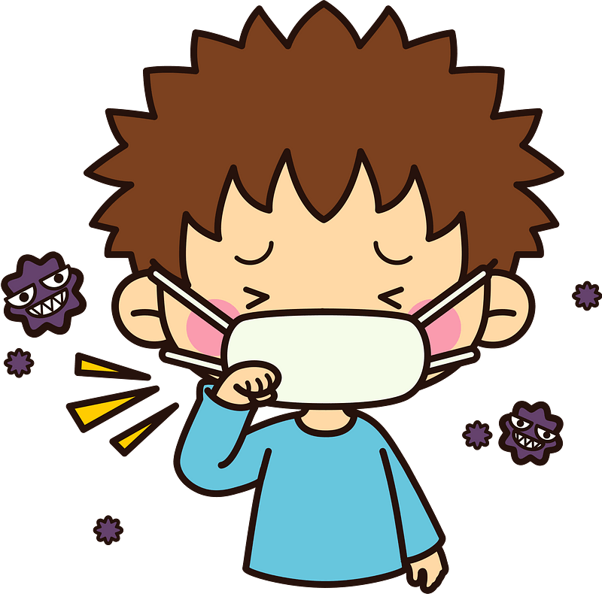 | 3- I was sick. ( )
 | 4- Mohammed kicked his new football. ( )
A-Put ( ✔ ) or ( X )

……\ 4 marks

Grammar
A-Choose the correct answer.
c-old | b-much | a- many | 1-How ……tomatoes do you have?
c-some | b-an | a-any | 2-They have ………cookies.
c-went | b-goes | a- go | 3- Last year , I ………to Japan.
c-much | b-many | a- any | 4- we don’t have …….fries.

Vocabulary

A.Choose the correct word under each picture
……\ 5 marks

 | 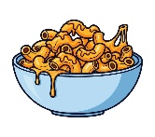 |  | 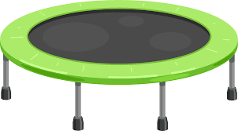 | 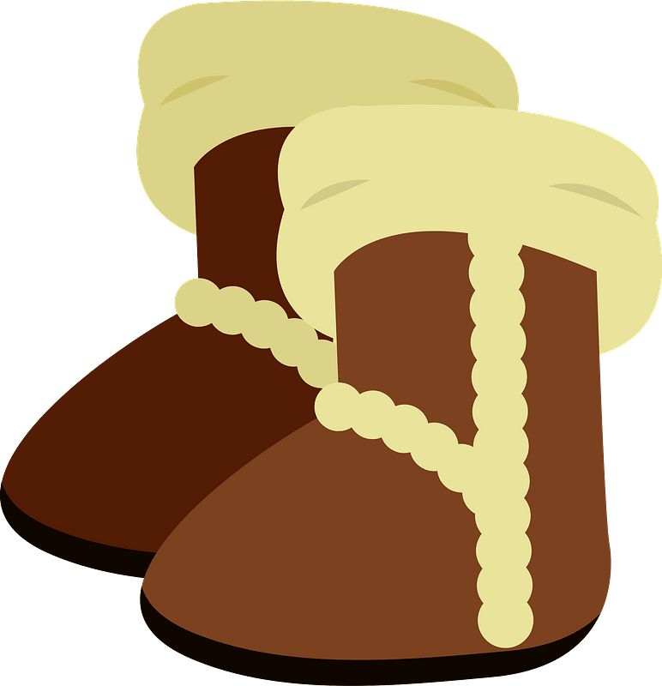
milk | macaroni | tree | Trampoline | boots
Salad | pizza | rocket | elephant | T-shirt
……\ 2 marks

Orthography
A. Fill in the missing letters

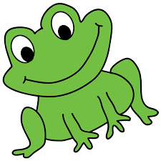
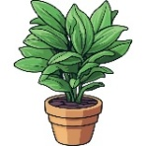
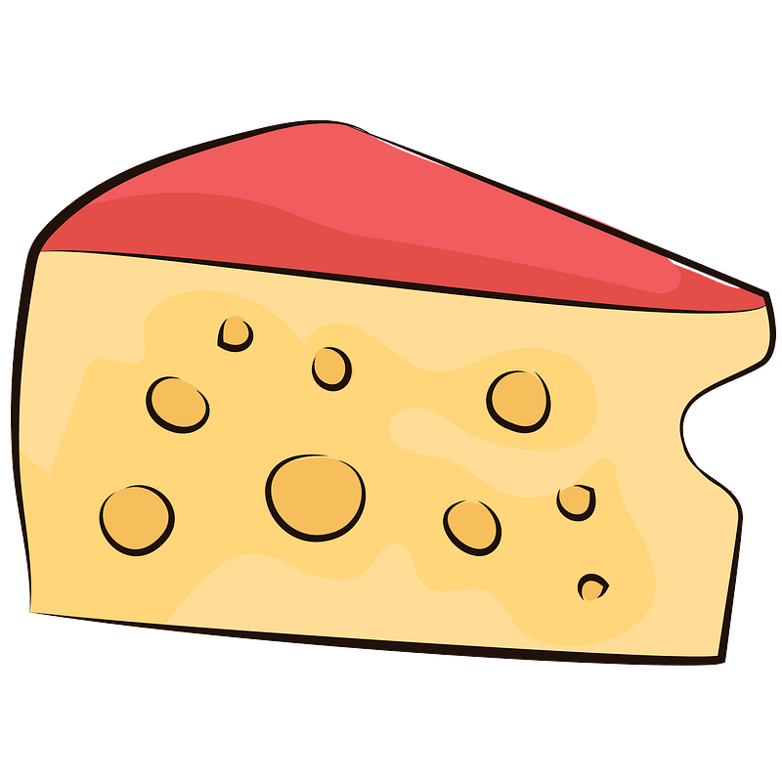
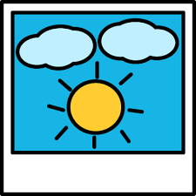

2-….rog
( th – r -f )

….rog
1-…..oto
(ph -gh – f )

…..oto
3-pla……
( cl – nt – gh)
4- c…eese
( r – o – h)

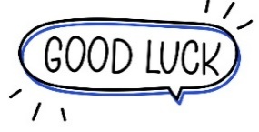
Your teacher:

Your teacher …..:…………………………….

